|  |  |  |
| --- | --- | --- |
| 1. | /ɑː/ | **Heart** / /hɑːt/, **Star** /stɑːr/, **Bar** /bɑːr/, **Guard** /gɑːrd/, **Aunt** /ɑːnt/ |
| 2. | /ʌ/ | **Money** /'mʌni/, **Some** /sʌm/, **Wonder**/ˈwʌndər/, **Dust** /dʌst/ |
| 3. | /e/ | **Check** /tʃek/, **Met** /met/, **Many** /'meni/, **Ready** /'redi/ |
| 4. | /æ/ | **Cat** /kæt/, **Bag** /bæg/, **Black** /blæk/, **Hand** /hænd/, **Map** /mæp/ |

1. **Form**
2. **Affirmative form**

|  |
| --- |
| I/ You/ We/ They + V.  He/ She/ It + V +s/es. |

* Ngôi thứ ba số ít thêm –s hoặc –es (thêm –es vào các động từ có tận cùng là o, s, x, z, ch, sh).

* Khi từ kết thúc bằng “y” thì có 2 cách chia: Trước “y” là môt nguyên âm thì ta giữ nguyên và thêm -s: play =>plays Trước “y” là môt phụ âm thì ta chuyển “y” -> “i”+ es: try => tries.

* Động từ bất quy tắc: do – does, go – goes, have – has.

**Ex:** I go to school at 07:00 AM every day.

She brushes her teeth every morning and night.

1. **Negative form**

|  |
| --- |
| I/ You/ We/ They + don’t + V.  He/ She/ It + doesn’t + V. |

**Ex:** We don’t live in England.

He doesn't often play soccer.

1. **Interrogative form**

|  |
| --- |
| Do + I/ You/ We/ They + V?  Does + He/ She/ It + V? |

**Ex:** Do you live here?

Does he play soccer?

1. **Use**
2. **Dùng để diễn tả thói quen hoặc những việc thường xuyên xảy ra ở hiện tại**

Về ý nghĩa này, thì hiện tại đơn thường xuất hiện những trạng từ hoặc cụm trạng từ như sau:

Always (luôn luôn), usually (thường xuyên), often (thường thường), frequently (thường xuyên), regularly (thường xuyên), sometimes (thỉnh thoảng), seldom (hiếm khi), rarely (hiếm khi), hardly (hiếm khi), never (không bao giờ),

Every day, every week, every month, every year… (Mỗi ngày, mỗi tuần, mỗi tháng, mỗi năm)

Once/ twice/ three times/ four times….. a day/ week/ month/ year,……. (một lần / hai lần/ ba lần/ bốn lần ……..một ngày/ tuần/ tháng/ năm)

**Ex:**My mother always gets up early.

I usually get up late on Sundays.

1. **Dùng để diễn tả những sự vật, sự việc xảy ra mang tính quy luật, các sự thật hiển nhiên, một chân lý, các phong tục tập quán, các hiện tượng tự nhiên.**

**Ex:**The earth goes around the sun.

The sun rises in the East and sets in the West.

1. **Dùng để diễn tả lịch trình của tàu, xe, máy bay hoặc các sự kiện**

**Ex:**The train leaves at 8 am tomorrow.

What time does the film begin?

**4. Diễn tả suy nghĩ, cảm xúc, cảm giác tại thời điểm nói**

**Ex:** I think that this Chinese course is really difficult.

Mary likes playing piano.

1. **How to pronounce when adding –s or -es**

|  |  |  |
| --- | --- | --- |
| **Danh từ có tận cùng bằng các âm** | **Phiên âm** | **Ví dụ** |
| Âm /k/, /t/, /p/, /f/, /θ/ | /s/ | Develops, stops, meets, laughs, breaths, chats, cooks, talks, thanks, waits, wants walks, tests, smokes, writes, etc. |
| Phụâm /s/, /z/,/tʃ/, /ʃ/, /ʤ/ | /iz/ | Changes, practices, recognizes, watches, washes, kisses, dances, causes, uses, manages, finishes, etc. |
| Cácâmcònlại | /z/ | Loves, names, gives, calls, cares, plays, hugs, needs, returns, reads, pays, listens, builds, enjoys, carries, etc. |

1. **Write correct words according to their phonetic symbols**

|  |  |  |  |  |  |
| --- | --- | --- | --- | --- | --- |
| 1. | /kɑːd/ | _______card__________ | 6. | /ʃel/ | ____shell_____________ |
| 2. | /'sʌni/ | ___________sunny______ | 7. | / lɑːrdʒ/ | _____larger____________ |
| 3. | /hed/ | _____head____________ | 8. | /hænd/ | ______hand___________ |
| 4. | /stɑːt/ | __________start_______ | 9. | /ə'gen/ | __________agent_______ |
| 5. | /mɑːtʃ/ | __________match_______ | 10. | /'mʌni/ | ___________money______ |

1. **Write phonetic symbols**

|  |  |  |  |  |  |
| --- | --- | --- | --- | --- | --- |
| 1. | Much | _______/mʌʧ/________ | 6. | Snack | _____/snæk/____________ |
| 2. | Laugh | ___________/laf/______ | 7. | Member | ____/ˈmɛmbə/_____________ |
| 3. | Happy | ____/hæpi/_____________ | 8. | Mother | _________/mʌðə/________ |
| 4. | Fan | ___/fæn/______________ | 9. | Bell | _______/bɛl/__________ |
| 5. | Nothing | _____/nʌθiŋ/____________ | 10. | Candle | _________/ˈkændl/________ |

1. **Question and answer**
2. What time do you wake up in the morning?

I wake up at six AM in the morning.

1. What do you usually have for breakfast?

I usually have a egg bread for breakfast.

1. What time do you eat lunch?

I eat lunch at half pass eleven o’clock

1. What do you do in the evening?

I study English, do my work.

1. What time do you usually go to bed?

I usually go to bed at twelve PM

1. Do you often iron the clothes?

No, I don’t. I often iron the clothes outside

1. What do you do at weekends?

I study English, do my work and go out

1. How often do you hang out with your friends on Saturday nights?

I often go to movie with my friends on Saturday nights.

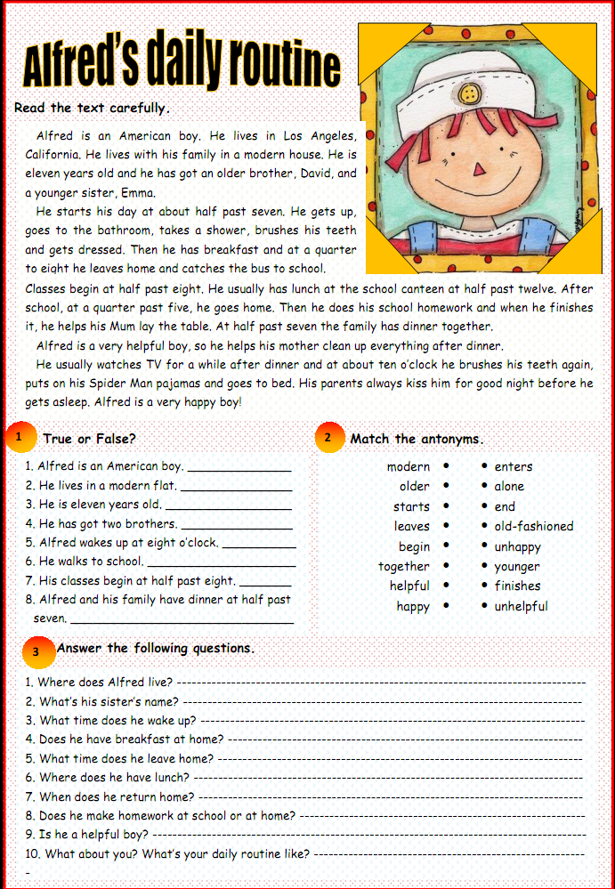

Muc 1:’

1. T
2. F
3. T
4. F
5. F
6. F
7. T
8. T

Muc 2:

1. modern >< old-fashioned
2. older >< young
3. starts >< finishes
4. leaves >< enters
5. begin >< end
6. together >< alone
7. helpful >< unhelpful
8. happy >< unhappy

Mục 3:

1. He lives in Los Angeles
2. His sister's name is Emma
3. He wake up at half past seven
4. Yes, He does
5. He leave home at a quarter to eight
6. He has lunch at the school canteen
7. He returns home at a quarter past five
8. yes, He does
9. Yes, he is